Year 7 Classification Revision Name: _________________________________

- What is another name for living things?
____________________________________________________________________________________________________
- Give two differences between dead living things and non-living thing.
____________________________________________________________________________________________________
____________________________________________________________________________________________________
- What are the 7 characteristics of living things?
____________________________________________________________________________________________________
____________________________________________________________________________________________________
- Use the dichotomous key to separate the following creatures
(use legs, no legs, horn, no horn, antenna, no antenna, etc)
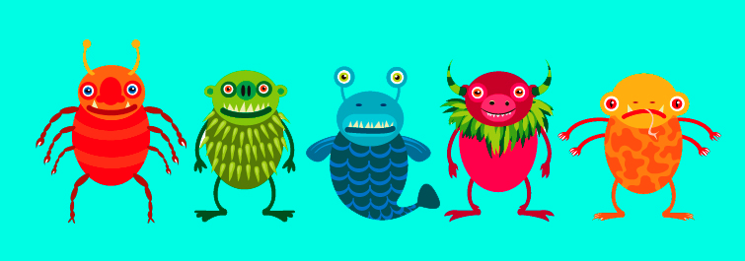

A B C D E

- Give the term used for the study of classification and naming organism. What do you call this expert.
____________________________________________________________________________________________________

- What is the main difference between a vertebrate and an invertebrate?
____________________________________________________________________________________________________

- Identify which is vertebrate (V) and which is invertebrate. (I)

Cuttlefish |  |  | Eel
Shark |  |  | Pig
Whale |  |  | Octopus
Jellyfish |  |  | Starfish
Grasshopper |  |  | Sea horse

- Which 2 groups of vertebrates are known as “warm-blooded”? Which are “cold-blooded”? What do they actually mean?
____________________________________________________________________________________________________
____________________________________________________________________________________________________
____________________________________________________________________________________________________
- There are three types of mammals: monotremes, marsupials and placentals. What are their differences? Give an example for each type.
____________________________________________________________________________________________________
____________________________________________________________________________________________________
____________________________________________________________________________________________________
____________________________________________________________________________________________________
- What are arthropods? Which are the 4 groups of arthropods?
____________________________________________________________________________________________________
____________________________________________________________________________________________________

- Cnidarians are a group of primitive animals living in the sea. Give one characteristics of Cnidarians and 3 examples.
____________________________________________________________________________________________________
____________________________________________________________________________________________________

- Complete the following table showing the characteristics of some invertebrates
Types of invertebrates: Crustacean, Echinoderm, Worm, Mollusc

Organism | Type of invertebrate | Characteristics
Sandworm |  | Tubular with no legs
Snail |  | Soft body covered by a shell
Sea Urchin |  | Spiny body with tube feet
Yabby |  | More than 8 legs with antennae and 2 body parts
Dragonfly |  | Three pairs of legs and 3 body parts and 2 pairs of wings
Millipede |  | Tubular in shape with many pairs of legs

- List the group of vertebrates: fish, mammal, reptile, amphibian, bird
a) _______________________ Having fur and feeding milk to their young
b) ______________________ Having fins for swimming and using gills for breathing
c) _______________________ Having rough, dry scaly skin and soft shelled eggs
d) ______________________ Having hard-shelled eggs and feather for flight
e) ______________________ Can live in water and on land with moist skin for breathing.

